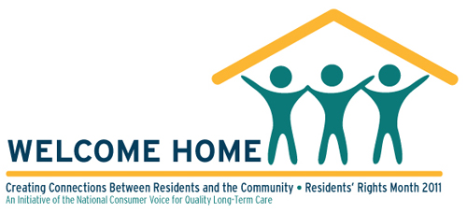
Residents’ Rights Report Sheet-2011

Volunteer Name: ________________________________________
Facility Name: ________________________________________
The learning circle activity took place on: _________________________________________
Number of staff present: __________
Number of residents present: __________
Number of family members present: __________
The facility is planning to hold more learning circles: Yes No
The facility also held (or plans to hold) other special events in recognition of Residents’ Rights month:
____________________________________________________________________________________
____________________________________________________________________________________
____________________________________________________________________________________
____________________________________________________________________________________
____________________________________________________________________________________

