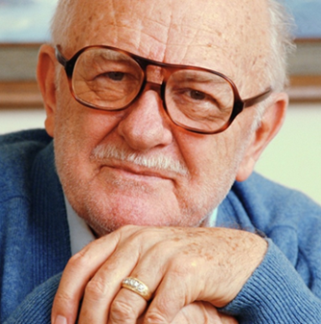
Let Me Return Home
When Nursing Homes Refuse To Allow Residents To Return Post-Hospitalization

training for hospital discharge planners

Thank you in advance for completing this short evaluation. Please circle your answer using the following scale:
1 – Poor; 2 – Below Average; 3 – Average; 4 – Above Average; 5 – Excellent
Overall, training met objectives: 1 2 3 4 5
Advocacy strategies helpful to me/my patients: 1 2 3 4 5
PowerPoint presentation content is: 1 2 3 4 5
Supplemental (take-away) Materials are: 1 2 3 4 5
Knowledge of trainer: 1 2 3 4 5
COMMENTS: ____________________________________________________________
________________________________________________________________________
________________________________________________________________________
________________________________________________________________________
________________________________________________________________________
________________________________________________________________________
I’d like to schedule another training session with colleagues. Please contact me to arrange it: ___________________________________________ [Name & Contact Info]

Office of Ombudsman for Long-term care
Minnesota board on Aging
Mailing address: PO Box 64971, St. Paul, MN 55164-0971
Site location: Elmer L. Andersen Human Services Building ● 540 Cedar St.● St. Paul, MN 55155
(651)431-2555 ● (800)657-3591 ● FAX (651)431-7452

