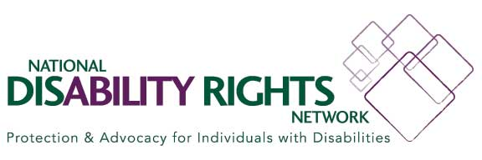
Ombudsman Program and Protection & Advocacy Agency Collaboration

Sample Memorandum of Understanding Template
Memorandum of Understanding

Between

(Partner)

and

(Partner)

This Memorandum of Understanding (MOU) sets the terms and understanding between the (partner) and the (partner) to (insert activity).

Background
(Why partnership important)

Purpose
This MOU will (purpose/goals of partnership)

The above goals will be accomplished by undertaking the following activities:
(List and describe the activities that are planned for the partnership and who will do what)

Reporting
(Record who will evaluate effectiveness and adherence to the agreement and when evaluation will happen)

Funding
(Specify that this MOU is not a commitment of funds)

Duration
This MOU is at-will and may be modified by mutual consent of authorized officials from (list partners). This MOU shall become effective upon signature by the authorized officials from the (list partners) and will remain in effect until modified or terminated by any one of the partners by mutual consent. In the absence of mutual agreement by the authorized officials from (list partners) this MOU shall end on (end date of partnership).

Contact Information
Partner name
Partner representative
Position
Address
Telephone
Fax
E-mail

Partner name
Partner representative
Position
Address
Telephone
Fax
E-mail

Date:
(Partner signature)
(Partner name, organization, position)

Date:
(Partner signature)
(Partner name, organization, position)

Note: This resource is part of series of materials regarding Ombudsman program and P&A collaboration, visit the NORC website for additional information on this topic.

This project was supported, in part, by grant number 90OM002, from the U.S. Administration for Community Living, Department of Health and Human Services, Washington, D.C. 20201. Grantees undertaking projects under government sponsorship are encouraged to express freely their findings and conclusions. Points of view or opinions do not, therefore, necessarily represent official Administration for Community Living policy.

