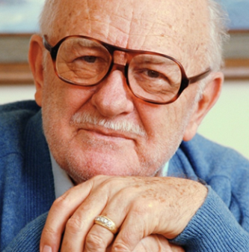
Let Me Return Home
When Nursing Homes Refuse To Allow Residents To Return Post-Hospitalization

training for hospital discharge planners

Welcome! Today’s training objectives are:

- Understand a patient’s/resident’s rights regarding involuntary discharge
- Understand several advocacy strategies for the patient/resident and their family
- Identify resources available to help patients/residents return to their nursing home

Please help us by estimating how many times you encounter nursing homes refusing to allow patients/residents to return:
In the last week? _____ In the last month? _____ In the past year? _____

If you’d like to receive more information, or be updated when new information regarding this topic is available, please provide your contact information below:

Name: ____________________________________________Date: _________________
Title: ___________________________________________________________________

Email: _______________________________________Phone:______________________

Thank You For Your Attendance Today!

Office of Ombudsman for Long-term care
Minnesota board on Aging
Mailing address: PO Box 64971, St. Paul, MN 55164-0971
Site location: Elmer L. Andersen Human Services Building ● 540 Cedar St.● St. Paul, MN 55155
(651)431-2555 ● (800)657-3591 ● FAX (651)431-7452

