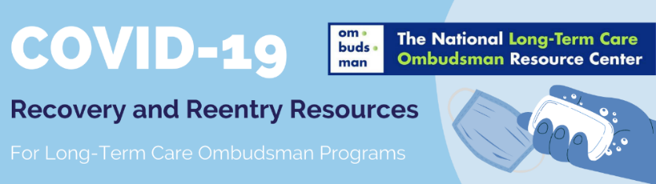
Tips for Communicating While Wearing a Mask
When Wearing a Mask | Show that You are Listening
- Make the resident feel safe, be friendly, set the scene.  - Imagine yourself as an actor. Use dramatic gestures and expressions.  - Show the resident what you are going to do before you start.  - Write things down for residents if it is helpful for the resident to better understand you (e.g., consider bringing a small dry erase board to show what you write).  - Follow-up to make sure the resident understands you.  - Consider wearing a laminated large photo of yourself with your title and program information so that residents can better see your face or identify you.  - Be conscious of your body language.  - Practice kindness, patience, and empathy. Visits may take longer. | - Nod to show you are listening and understanding.  - Maintain good eye contact.  - Let your eyebrows tell the story.  - Face the resident and try not to turn away when speaking.
 | Show How You Are Feeling
- Happiness: smile, raise eyebrows
- Concern: eyebrows pinched together and eyes drooping
- Remember: eyebrows in a “V” can mean “angry”
 | Be Aware of How You are Speaking
- Be calm: speak clearly and use short, simple sentences.
- Try not to speak too loudly, too softly, or too fast or slow.
- Consider use of a portable voice amplifier.
- Say one thing at a time.
- Pause after asking questions.
Suggestions for Maintaining Physical Distance
- Prior to your visit identify how the facility is accommodating visits. Is the visitation to take place outside, in a quiet specified room inside, or resident’s room?
- Ensure that you and the resident are separate by at least 6 feet.
- Tell the resident that you wish you could shake their hand or give them a hug (if you know them well), but that because of the virus we need to maintain distance, be careful, and look out for each other.
- Residents with dementia or behavioral health needs may have trouble understanding physical distancing protocols. To help you maintain physical distance it may be helpful to identify something to occupy their attention, such as:
- Ask staff for a snack or drink for the resident.
- If the visit is outside and the resident smokes, visit while the resident smokes (if the smoke does not bother you).
- Ask the staff if the resident has a favorite hobby and if some of those items can be available during your visit.
- Ask staff for how they ensure physical distance between the resident and visitors.
- If visiting outside, it may be helpful to walk and talk, as appropriate.

NOTE: Follow public health guidance regarding infection control and protection and federal (cdc.gov, cms.gov, acl.gov) and state guidance regarding visits to facilities. Refer to NORC’s COVID-19 Recovery and Reentry Resources for additional information regarding safety, visits, and complaint handling during the pandemic.
August 2020
This project was supported, in part, by grant number 90OMRC0001-01-00, from the U.S. Administration for Community Living, Department of Health and Human Services, Washington, D.C. 20201. Grantees undertaking projects under government sponsorship are encouraged to express freely their findings and conclusions. Points of view or opinions do not, therefore, necessarily represent official Administration for Community Living policy.

