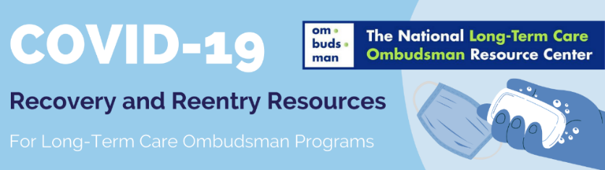
Tips for Facility Visits
During an Infectious Disease Outbreak
REMINDERS! Follow public health guidance regarding infection control and protection and federal (cdc.gov, acl.gov) and state guidance regarding visits to facilities.
Follow guidance for handwashing, self-care, and physical distancing. DO NOT conduct facility visits if you have any sickness (fever, cough, shortness of breath, etc.) or been exposed to someone with infectious disease symptoms in the last 14 days. Reschedule visits or if necessary, arrange for another representative to visit. Seek further guidance from the Office of the State Long-Term Care Ombudsman.
Preparing & Arriving for a Visit
What to Bring  - Bring only items necessary for the visit such as your ID badge, laptop, and required paperwork.  - Store personal items (e.g., phone, purse, backpack) securely in your vehicle, if possible.  - Sanitary Kit In a sealable bag, include:  - Hand soap  - Hand sanitizer (at least 60% alcohol)  - Paper towels (entire roll may not be necessary)  - Disinfectant wipes (do not take spray into facility)  - Bag for disposal of used items  - Masks Wear a cloth mask with multiple layers of fabric or a disposable mask under a cloth mask. Do not use two disposable masks. Do not combine a KN95 mask with another mask. In addition, it may be necessary to have available face shields, gowns, and disposable gloves. | Arrival and Greeting  - Determine ahead of time where you will meet residents, (e.g., outdoors, window visits, or in a specific room).  - Greet residents and staff verbally.  - Avoid physical contact, such as:  - Handshakes - Hugs  - Fist bumps  - Avoid placing belongings on tabletops, floors, or chairs that might have high levels of germs.  - If possible, maintain the recommended six feet distance between people.  - Avoid touching surfaces, especially:  - Doorknobs - Bed rails  - Handles - Wheelchairs  - Light switches
Cleaning and Sanitizing During & Between Visits
Cleaning and Sanitizing  - Wash hands at a sink for at least 20 seconds at the time of arrival, between visits in a resident’s room, at departure, and as needed.  - It is okay to use the supplies provided by the facility for washing hands. However, take your sanitary kit in with you in case adequate supplies are not available.  - Use hand sanitizer in situations when hand washing not readily available.  - Avoid touching your eyes, nose, and mouth.  - Avoid eating and drinking while at facility. | Supplies  - Clean and sanitize the following items between facility visits and/or as needed.  - Mobile phone - Eyeglasses  - Pen, clipboard, and outside of laptop - Car keys - Any additional items  - Name badge  - Properly dispose of PPE after use. If PPE is not disposable, wash, spray, or wipe with disinfectant between visits.
Protecting Yourself and Others
- Everyone is encouraged to get fully vaccinated against COVID-19. Fully vaccinated is defined as two weeks after completion of the vaccination process (either 1 or 2 shots).
- For information about finding a vaccine visit the CDC website, or contact your local health department, medical provider, or pharmacist.
- Scientists have not yet determined whether vaccinated people may still unknowingly spread the COVID-19 virus. Once you have been vaccinated, continue to wear a mask, maintain a physical distance of six feet, and wash hands frequently.
This project was supported, in part, by grant number 90OMRC0001-01-00, from the U.S. Administration for Community Living, Department of Health and Human Services, Washington, D.C. 20201. Grantees undertaking projects under government sponsorship are encouraged to express freely their findings and conclusions. Points of view or opinions do not, therefore, necessarily represent official Administration for Community Living policy.
Revised April 2021 with updated information obtained from CDC.gov

